OBJECT TO THE APPEAL
Help save this beautiful field on Turners Green Road from housing development

Closing date for objections: Thursday 15 April
This scheme does not meet local housing needs. It destroys a well-used, historic public footpath.
How to object:
- Online via the Appeals Casework Service website (https://acp.planninginspectorate.gov.uk).
- In writing (enclosing 3 copies of signed letter), send to: The Planning Inspectorate, Room: 3B Eagle Wing, Temple Quay House, 2 The Square, Temple Quay, BRISTOL BS1 6PN.
Please quote: APP/C1435/W/20/3265921 in correspondence
Use the objections overleaf:
The objections to include in your response can be copied from the list overleaf.
Each person in your household can object.
Every name counts and every comment matters.

Thank you for your support of this campaign
REASONS TO OBJECT
1)The site is outside of the development boundary.
2)The site is in High Weald Area of Outstanding Natural Beauty (AONB). AONB’s are afforded great protection in the National Planning Policy Framework Document 2019 (NPPF). The elevation of the site means the development would be very visible from the surrounding countryside, especially since the site is not connected to other dwellings.
3)The Appeal proposes constructing a concrete footpath from the corner of the site next to the recreation ground, across the uneven cobbled carpark, around the corner, to join the existing footpath in South View Road. This would destroy the grass verge, is likely to affect the hedgerows, and interfere with their roots. The verges and hedgerows are rich in vegetation and provide habitats for wildlife. It would also damage 2 mature trees in its path on South View Road.
4) Construction of such a footpath would narrow the already narrow portion of South View Road, making it hazardous. Construction would involve increased traffic, heavy vehicles and further hazards on the narrow lanes. The Appeal does not mention adding street lighting.
5) The proposal would not protect the rare species in the vicinity, such as bats, badgers, dormice, deer, newts, hedgehogs, grass snakes and slow worms, or their habitats.
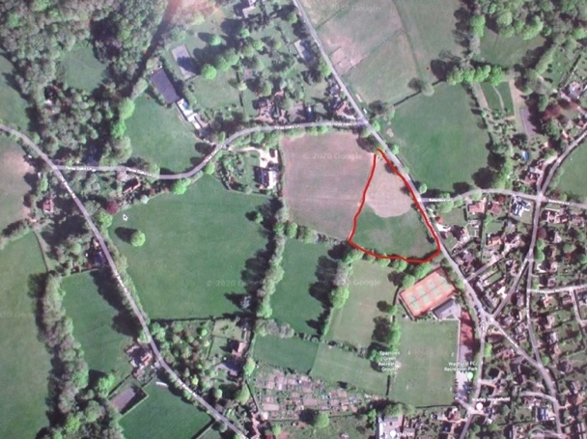
6) The proposed cul-de-sac would destroy the medieval patchwork of fields typical of the High Weald. It would be very obvious perched on the high ridge.
7) The site has a historic public footpath (Wadhurst 46) crossing it. The proposed development would destroy the enjoyment of this well used footpath. It would become a tarmacked route running through an urban cul-de-sac.
8) Flooding risk. The run off from the field already gushes down Three Oaks Lane. The proposal includes adding a concrete footpath on a hill, which would increase the volume of water surging down Turners Green Road into Three Oaks Lane.
9) The site is not within walking or cycling distance to amenities. It is 1.9km from Wadhurst centre.

